Types of servers
# Source: Chatgpt (GPT-5-Mini) at [1/16/2026]
There are many types of servers, each designed to perform specific tasks within a network or system. Below is a categorized breakdown of the most common types of servers, with simple explanations and real-world examples.

🏗️ Types of Servers — By Deployment
# Source: Chatgpt (GPT-5-Mini) at [1/16/2026]
Categorized by how and where servers are installed, hosted, or accessed.

🧩 Types of Servers — By Function
# Source: Chatgpt (GPT-5-Mini) at [1/16/2026]
Categorized by what the server does — its role or service in the network.

Basic server types photo
# Source: [Data Path: Miscellaneous Folder -> Miscellaneous Database -> Miscellaneous Table -> ID: 29] at [1/16/2026]
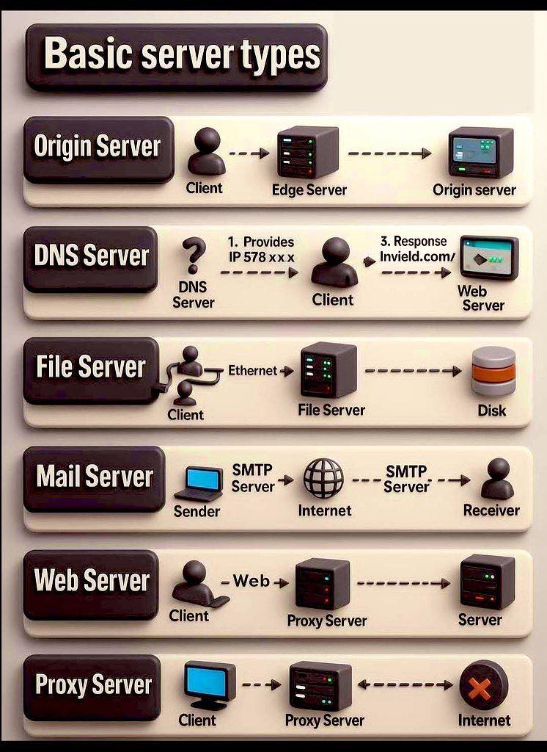

Server Type Main Function photo
# Source: Data Path: Miscellaneous Folder -> Miscellaneous Database -> Miscellaneous Table -> ID: 27
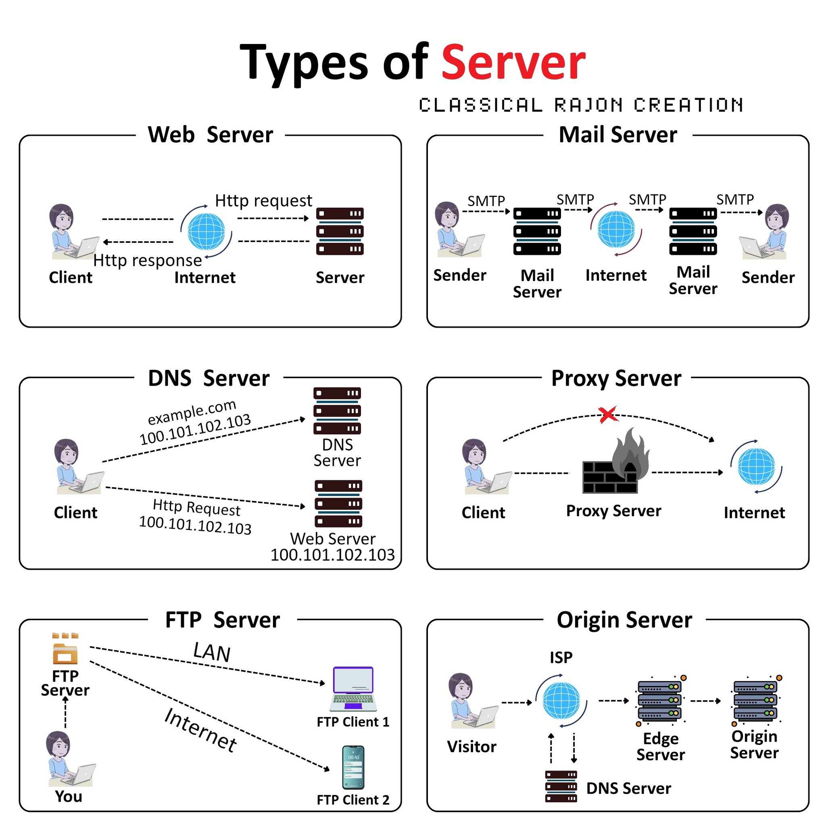

🔹 1. Web Server
# Source: Chatgpt (GPT-5-Mini) at [1/16/2026]
- Purpose: Serves websites and web apps.
- Examples: Apache, Nginx, Microsoft IIS
- Use Case: Delivering HTML, CSS, JS, images, etc.
🖥️ You type example.com → the web server responds with the website.

🔹 2. Database Server
# Source: Chatgpt (GPT-5-Mini) at [1/16/2026]
- Purpose: Stores and manages data for apps.
- Examples: MySQL, PostgreSQL, Oracle, SQL Server
- Use Case: Backend of websites, storing user data, transactions, etc.
🗄️ Used by apps like Facebook to store posts, users, messages, etc.

🔹 3. File Server
# Source: Chatgpt (GPT-5-Mini) at [1/16/2026]
- Purpose: Stores and shares files over a network.
- Examples: Windows File Server, Samba, FTP servers
- Use Case: Centralized file storage for businesses or local networks.
📁 Employees in an office access shared documents from a file server.

🔹 4. Mail Server
# Source: Chatgpt (GPT-5-Mini) at [1/16/2026]
- Purpose: Sends, receives, and stores emails.
- Examples: Microsoft Exchange, Postfix, Exim
- Use Case: Email hosting for companies or domains.
📧 Handles emails like you@yourdomain.com.

🔹 5. Application Server
# Source: Chatgpt (GPT-5-Mini) at [1/16/2026]
- Purpose: Runs backend logic or app code.
- Examples: Apache Tomcat, JBoss, Node.js servers
- Use Case: Middleware between front end and database.
⚙️ Used in systems where code (like Java, PHP) runs on the server side.

🔹 6. DNS Server (Domain Name System)
# Source: Chatgpt (GPT-5-Mini) at [1/16/2026]
- Purpose: Translates domain names to IP addresses.
- Examples: BIND, Google DNS, Cloudflare DNS
- Use Case: You type google.com, DNS tells your browser the IP to connect to.
🌐 Works like the phone book of the internet.

🔹 7. Proxy Server
# Source: Chatgpt (GPT-5-Mini) at [1/16/2026]
- Purpose: Acts as a gateway between users and the internet.
- Examples: Squid, HAProxy
- Use Case: Caching, filtering, security, load balancing.
🔒 Can block websites, speed up browsing, or anonymize requests.

🔹 8. DHCP Server (Dynamic Host Configuration Protocol)
# Source: Chatgpt (GPT-5-Mini) at [1/16/2026]
- Purpose: Automatically assigns IP addresses to devices.
- Examples: Windows DHCP, Cisco routers
- Use Case: Wi-Fi router gives your phone an IP when you connect.
📡 You join a network — DHCP gives your device a unique address.

🔹 9. FTP Server (File Transfer Protocol)
# Source: Chatgpt (GPT-5-Mini) at [1/16/2026]
- Purpose: Transfers files over the internet.
- Examples: vsftpd, FileZilla Server
- Use Case: Uploading/downloading files to a web host.
⬆️ Web developers upload websites to a server via FTP.

🔹 10. Game Server
# Source: Chatgpt (GPT-5-Mini) at [1/16/2026]
- Purpose: Hosts multiplayer game sessions.
- Examples: Minecraft Server, Steam Dedicated Server
- Use Case: Real-time communication for multiplayer games.
🎮 You and friends connect to the same server to play online.

🔹 11. Virtual Server
# Source: Chatgpt (GPT-5-Mini) at [1/16/2026]
- Purpose: A software-based emulation of a physical server.
- Examples: VMware, Hyper-V, VirtualBox
- Use Case: Hosting multiple "servers" on one machine.
🧱 One physical computer runs multiple virtual environments.

🔹 12. Cloud Server
# Source: Chatgpt (GPT-5-Mini) at [1/16/2026]
- Purpose: On-demand server hosted in the cloud.
- Examples: AWS EC2, Google Cloud Compute, Azure VMs
- Use Case: Scalable, flexible infrastructure for apps or websites.
☁️ Spin up or down servers without owning physical hardware.

🔹 13. Print Server
# Source: Chatgpt (GPT-5-Mini) at [1/16/2026]
- Purpose: Manages print jobs on a network.
- Examples: CUPS (Linux), Windows Print Server
- Use Case: Centralized printing in offices or schools.
🖨️ Sends and manages documents sent to printers from many users.
Great! Let’s add the additional server types you mentioned — Catalog Server, Communication Server, Computing Server, Fax Server — and update the full list for a complete reference.

🔹 14. Catalog Server
# Source: Chatgpt (GPT-5-Mini) at [1/16/2026]
- Purpose: Helps users locate data, files, or services in large distributed systems or networks.
- Use Case: Enterprise environments, data warehouses, distributed databases.
- Example: Microsoft Indexing Service, custom-built metadata catalog services.
🔎 Acts like a searchable directory for data in large systems.

🔹 15. Communication Server
# Source: Chatgpt (GPT-5-Mini) at [1/16/2026]
- Purpose: Manages messaging, voice, video, and collaboration services.
- Use Case: Real-time chat, email, video conferencing, VoIP.
- Examples: Microsoft Teams Server, Cisco Unified Communications Manager.
📞 Handles chat, calls, and conferencing across teams or customers.

🔹 16. Computing Server
# Source: Chatgpt (GPT-5-Mini) at [1/16/2026]
- Purpose: Provides high processing power for complex calculations or workloads.
- Use Case: Scientific simulations, AI, data analytics, rendering.
- Examples: HPC clusters, GPU servers (NVIDIA DGX), Compute nodes in cloud (AWS EC2, GCP Compute).
💻 Runs resource-intensive tasks like AI models, rendering, simulations.

🔹 17. Fax Server
# Source: Chatgpt (GPT-5-Mini) at [1/16/2026]
- Purpose: Sends and receives digital faxes via the network.
- Use Case: Healthcare, legal, finance, or government offices.
- Examples: GFI FaxMaker, HylaFAX.
📠 Allows users to fax from their computer without physical fax machines.

Physical vs Virtual vs Cloud Servers
# Source: Chatgpt (GPT-5-Mini) at [1/16/2026]
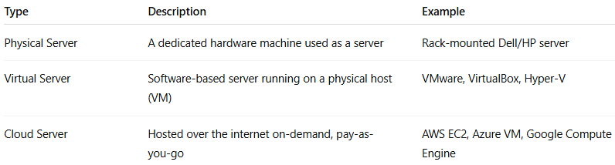
Type | Description | Example
Physical Server | A dedicated hardware machine used as a server | Rack-mounted Dell/HP server
Virtual Server | Software-based server running on a physical host (VM) | VMware, VirtualBox, Hyper-V
Cloud Server | Hosted over the internet on-demand, pay-as-you-go | AWS EC2, Azure VM, Google Compute Engine

✅ Summary Table
# Source: Chatgpt (GPT-5-Mini) at [1/16/2026]
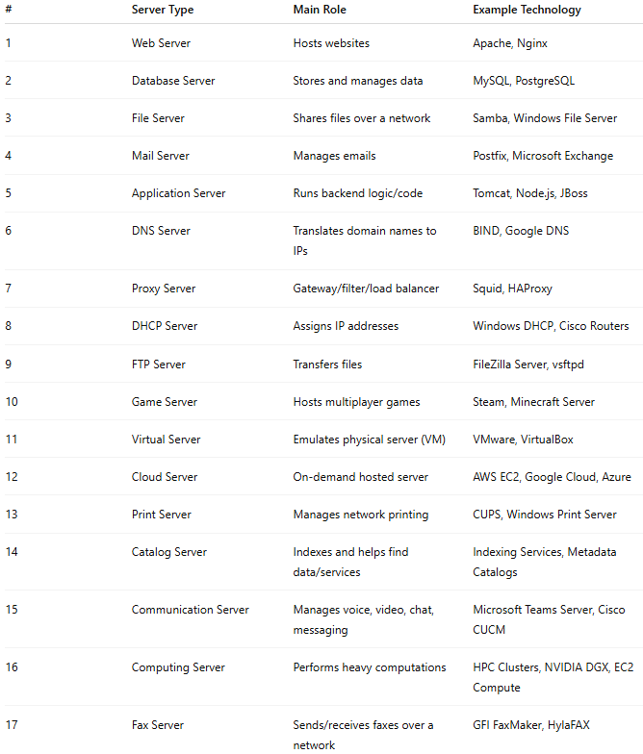

# | Server Type |  | Main Role | Example Technology
1 |  | Web Server | Hosts websites | Apache, Nginx
2 |  | Database Server | Stores and manages data | MySQL, PostgreSQL
3 |  | File Server | Shares files over a network | Samba, Windows File Server
4 |  | Mail Server | Manages emails | Postfix, Microsoft Exchange
5 |  | Application Server | Runs backend logic/code | Tomcat, Node.js, JBoss
6 |  | DNS Server | Translates domain names to IPs | BIND, Google DNS
7 |  | Proxy Server | Gateway/filter/load balancer | Squid, HAProxy
8 |  | DHCP Server | Assigns IP addresses | Windows DHCP, Cisco Routers
9 |  | FTP Server | Transfers files | FileZilla Server, vsftpd
10 |  | Game Server | Hosts multiplayer games | Steam, Minecraft Server
11 |  | Virtual Server | Emulates physical server (VM) | VMware, VirtualBox
12 |  | Cloud Server | On-demand hosted server | AWS EC2, Google Cloud, Azure
13 |  | Print Server | Manages network printing | CUPS, Windows Print Server
14 |  | Catalog Server | Indexes and helps find data/services | Indexing Services, Metadata Catalogs
15 |  | Communication Server | Manages voice, video, chat, messaging | Microsoft Teams Server, Cisco CUCM
16 |  | Computing Server | Performs heavy computations | HPC Clusters, NVIDIA DGX, EC2 Compute
17 |  | Fax Server | Sends/receives faxes over a network | GFI FaxMaker, HylaFAX

